**GIS Assignment 1.**

C12355251 Ronan Dillon

1. **Highly Educated / Workforce**

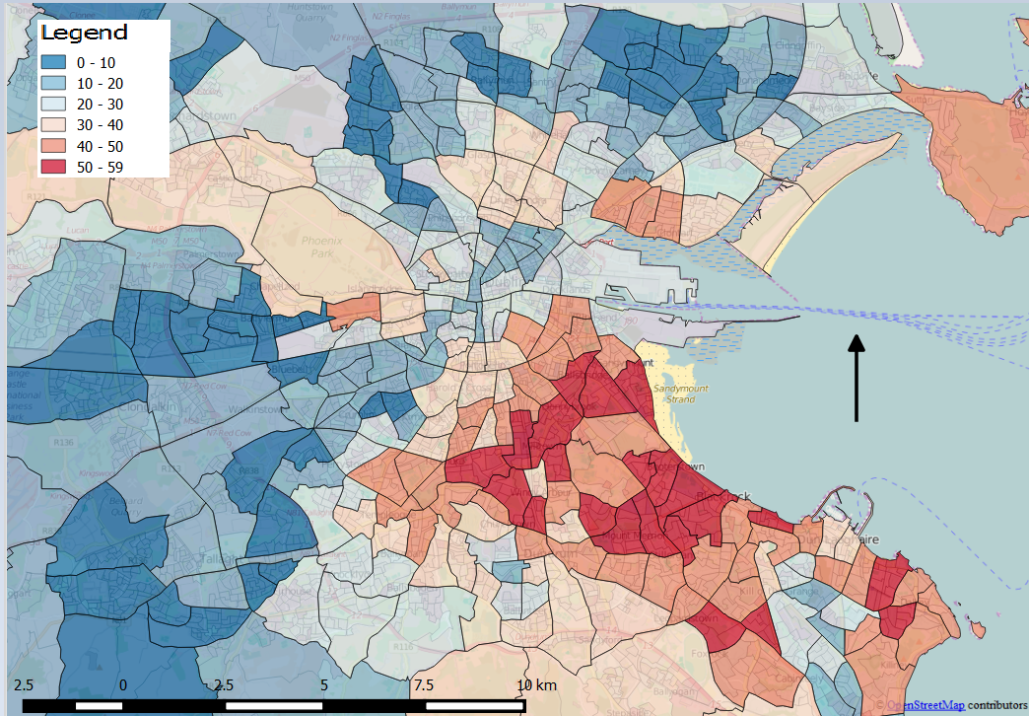

The area in which I chose to do my research was the Dublin city area and surrounding towns. I have done my research using the electoral divisions data as I felt it gave the perfect overview of the area, if the divisions were smaller it would be overly detailed and with bigger divisions it would become too vague. The first map above shows the percentage of highly educated people (someone with an honours bachelor’s degree or higher) against the total workforce (the sum of people in work, people looking for their first job and people who are unemployed having lost or given up their previous job).

It is generally said that in Dublin city that there is a class difference between the north and south sides of the River Liffey. From this map and others that can be found below I would argue that on the south side of the River Liffey specifically there is a spilt in class in the east to the west. This map suggests that in areas in the south east of Dublin, the workforce is in general higher educated than areas in the south west of Dublin.

1. **Skilled Jobs / At Work**

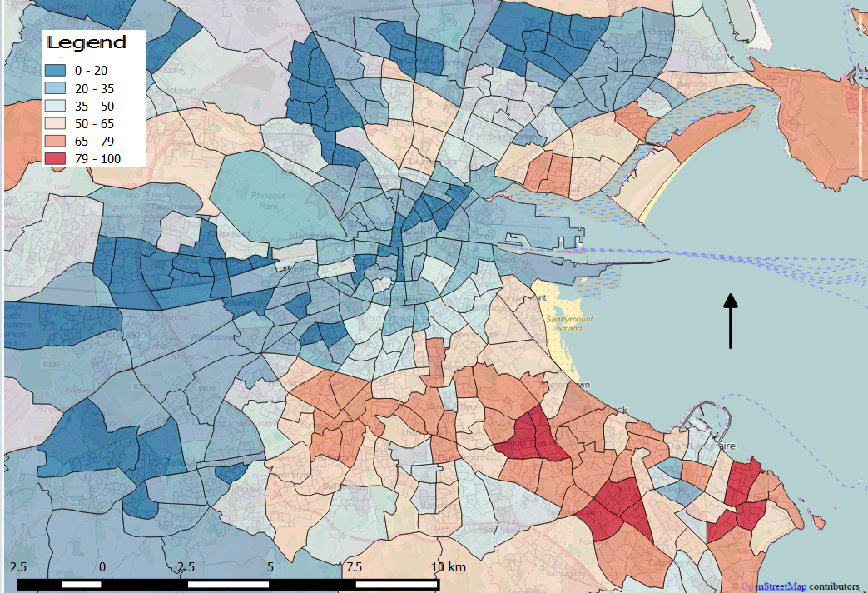

This map shows the percentage of skilled jobs (Employers and managers, Higher professional and Lower professional) against the total number of people working. Similar to the first map there is a pattern in south Dublin, the south east has a high percentage of skilled jobs whereas the west has a low percentage.

The two maps together have a similar trend in that they both have high percentages in the south east area of Dublin. It would suggest that a person with a higher degree would increase their likelihood of acquiring a more skilled job.

1. **Out Of Work / WorkForce**

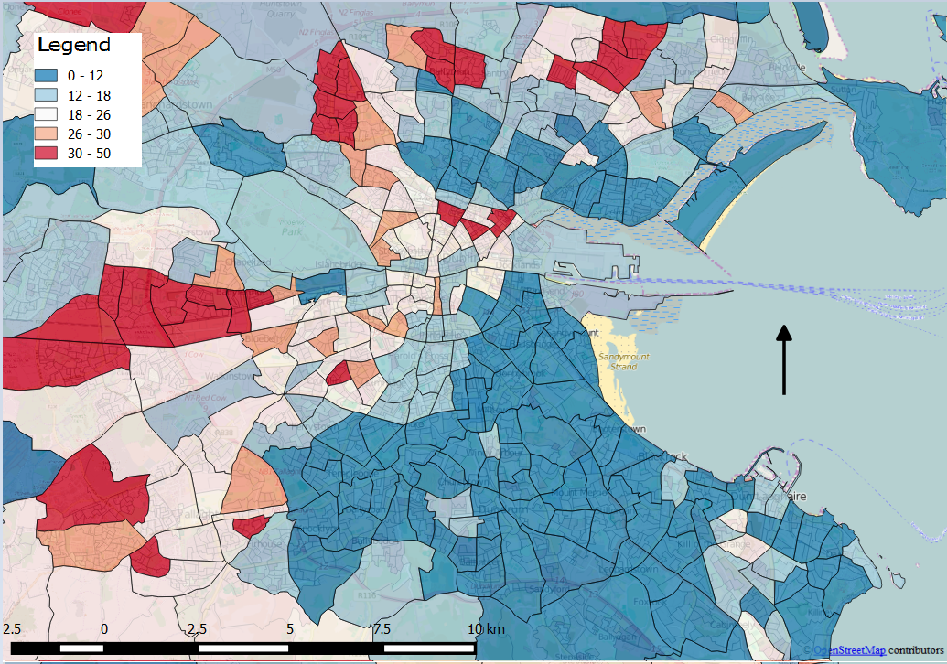

This map shows the percentage of people out of work (the sum of people searching for there first job and people who are unemployed having given up or lost their last job) against the total workforce. The map shows that a much higher percentage of people in south west Dublin are looking for work when compared to south east Dublin which has a significantly lower percentage.

1. **Highly Educated / Total Population**

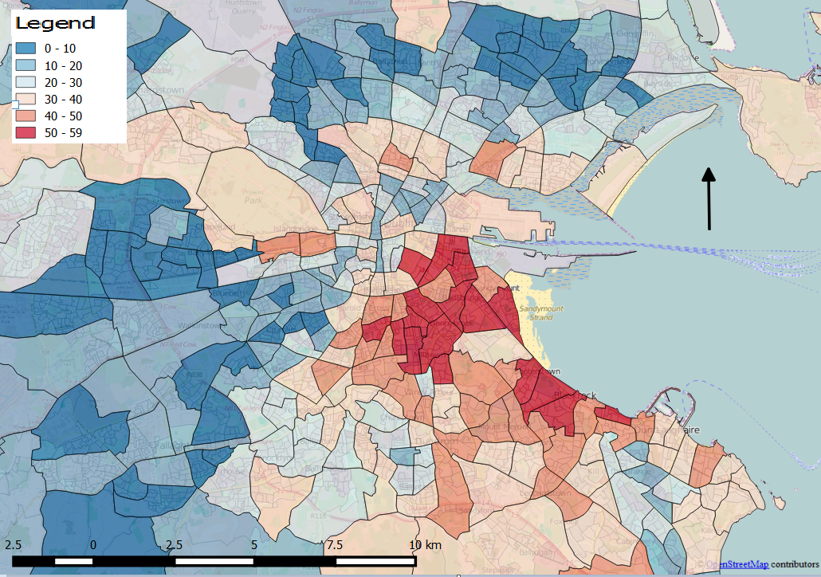

This map shows the highly educated population against the total population of the area. Areas in the south west and far north of the city reach as low as under ten percent of the total population. Whereas areas in the south east have over fifty percent of the population highly educated. Areas in the north city centre also contain high levels of highly educated people.   
  
 Map 4 below is almost the inverse of Map 3. It shows lowly educated people which includes people who have had no form of education. Again the divide between south east and south west Dublin is apparent with high levels of lowly educated people in the west and low levels in the east.

1. **Lowly Educated/ Total Population**

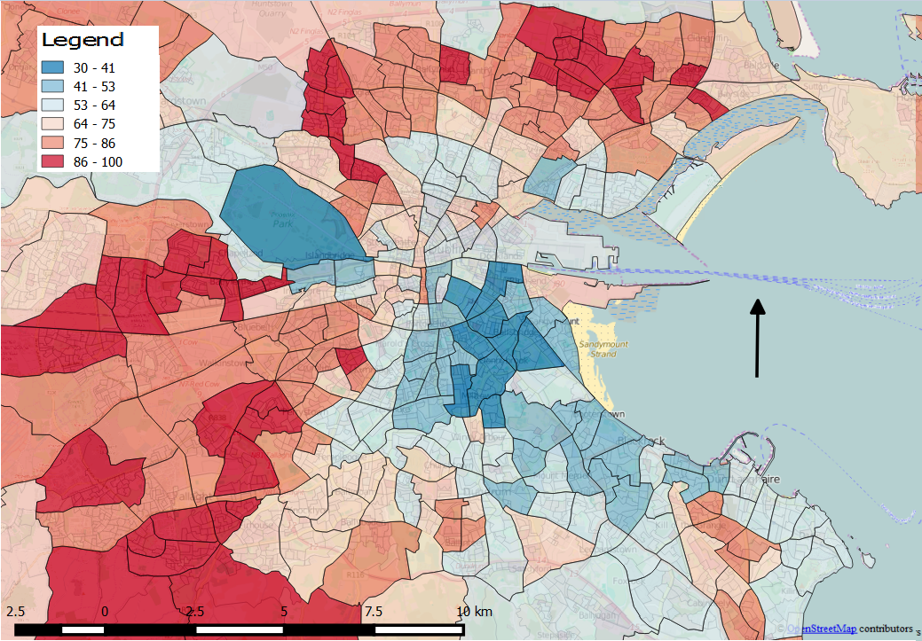

To conclude my research I would say that there is a correlation between educational achievement and employment prospects and that educational achievement is inordinately concentrated in certain areas. I believe the data I have given backs up that statement.